

**Container And Docker Security**

***LAB FILE SUBMITTED BY: SUBMITTED TO:***

**NAME: Stuti Sehgal Dr. Hitesh Kumar Sharma Sir**

**SAP ID: 500107063**

**BATCH: 2 Devops**

**EXPERIMENT 1**

**Lab Exercise: Introduction to Vagrant and Vagrantfile.**

**This exercise will guide them through setting up a virtual environment using Vagrant, configuring the environment via a Vagrantfile, and managing the virtual machines (VMs) with basic Vagrant commands.**

**Objective:**

* **Learn how to set up and configure virtual environments using Vagrant.**
* **Understand the structure and components of a Vagrantfile.**
* **Gain hands-on experience in managing virtual machines using Vagrant commands.**

**Prerequisites:**

* **Basic knowledge of virtualization concepts.**
* **Familiarity with command-line interfaces.**
* **Installation of Vagrant and VirtualBox (or any other supported provider) on your local machine.**

**Step-by-Step Exercise:**

**1. Setting Up the Environment:**

**Install Vagrant:**

* **Download and install Vagrant from the official website.**
* **Ensure you have VirtualBox installed as it is a commonly used provider with Vagrant.**
* **Verify Installation:**
* **Open a terminal or command prompt.**
* **Run the following commands to verify the installation:**

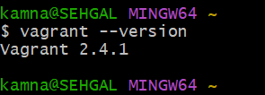

**2. Creating a New Vagrant Project:**

* **Create a Project Directory:**
* **In your terminal, create a new directory for your Vagrant project and navigate into it:**

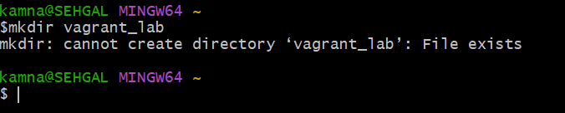



**Initialize Vagrant:**

* **Run the following command to initialize a new Vagrantfile in your project directory:**

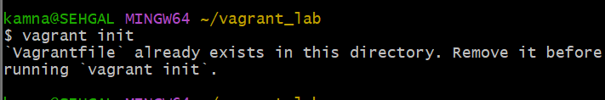

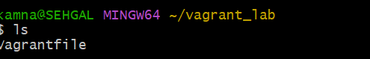

**This command will generate a Vagrantfile in the current directory.**

**3. Understanding the Vagrantfile:**

* **Open the Vagrantfile:**
* **Open the Vagrantfile in a text editor of your choice.**
* **The Vagrantfile is a Ruby-based configuration file used to define the virtual environment.**
* **Basic Vagrantfile Configuration:**
* **Modify the Vagrantfile to configure a basic virtual machine. For example:**

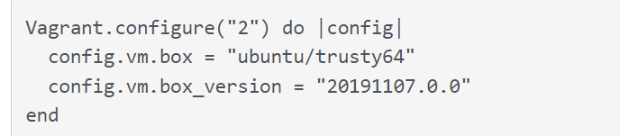

**4. Launching and Managing the VM:**

**Start the VM:**

**In the terminal, start the VM using the following command:**

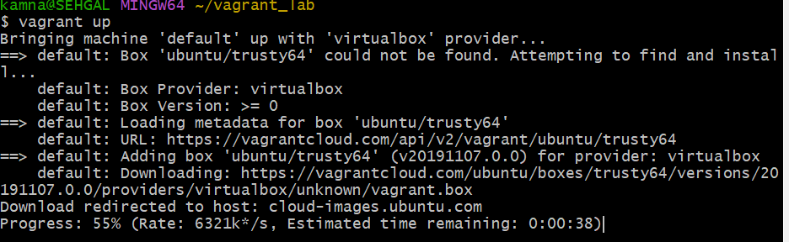

**Vagrant will download the specified box (if not already downloaded) and launch the VM.**

* **SSH into the VM:**
* **Connect to the running VM using SSH:**

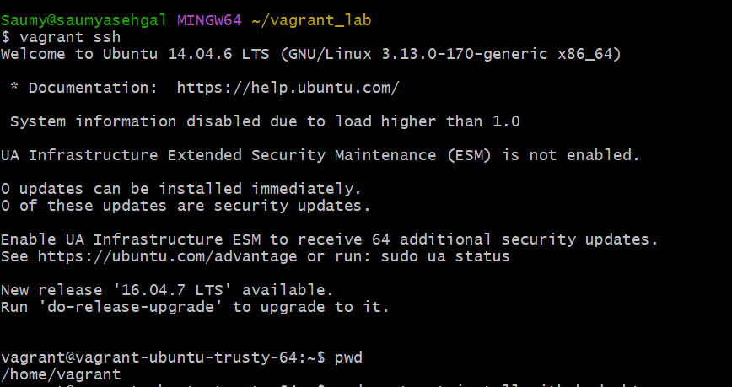

* **This command will log you into the VM’s shell.**
* **Exploring the VM:**

**Inside the VM, explore the filesystem, install packages, and run commands to understand the environment.**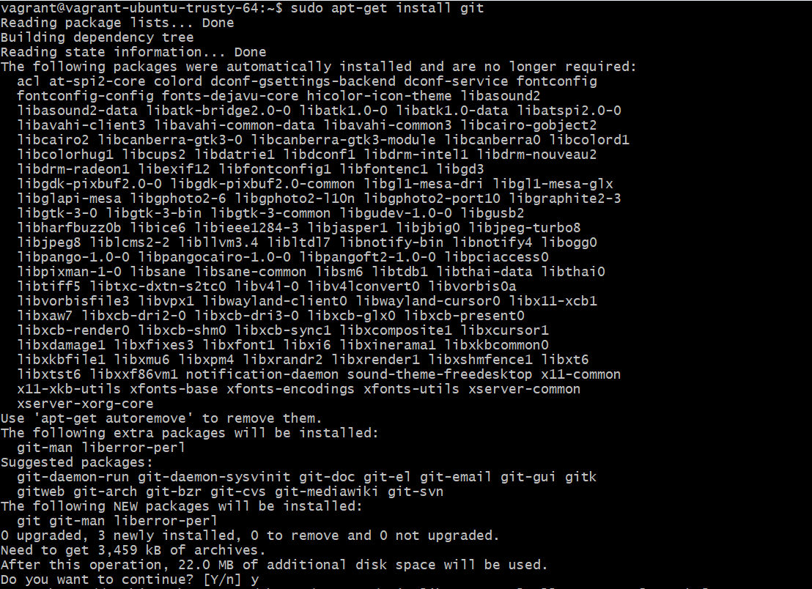

* **Stop the VM:**
* **Exit the SSH session by typing exit.**

* **Stop the VM with the following command:**

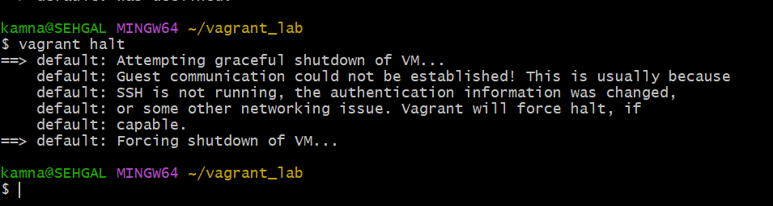

**Destroy the VM (optional):**

**To remove the VM completely, use the following command:**

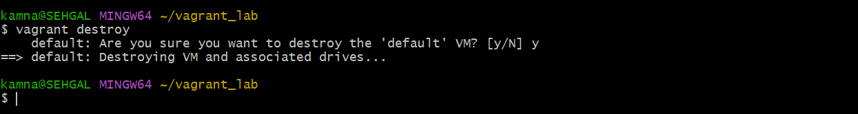

**This will remove all traces of the VM, including any data stored on it.**

**Explore the benefits of using Vagrant for development and testing environments.**